**Learning Outcomes**

1. Handling XML RSS feeds

**Design Screen**

Handling XML feeds and showing it in a listview.

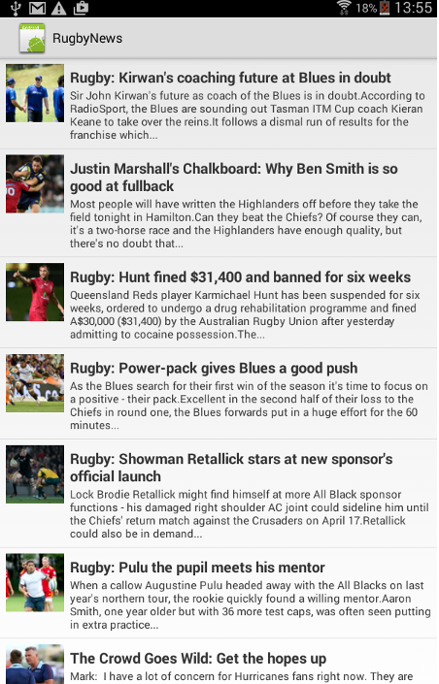

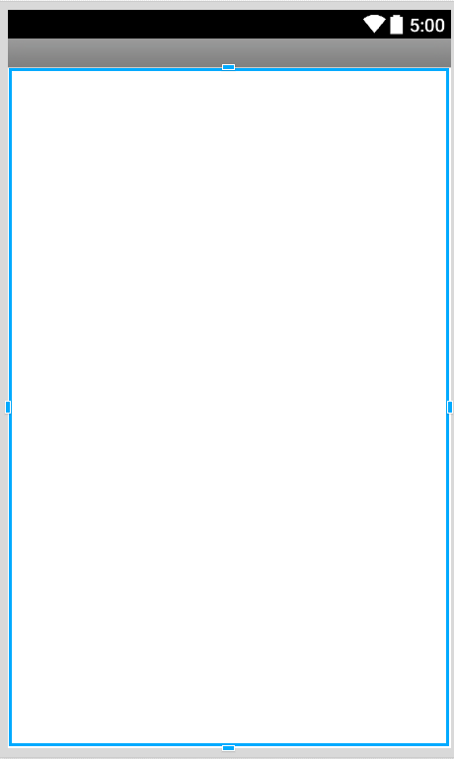

Main.axml has a listview

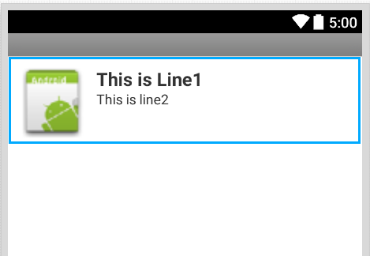

CustomRow.axml

**RSS feed**

We access the RSS feed from the NZ herald website http://www.nzherald.co.nz/rss/

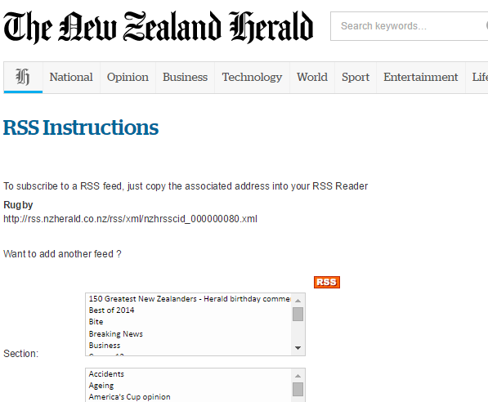

Feed for rugby is

http://rss.nzherald.co.nz/rss/xml/nzhrsscid_000000080.xml

**Convert the XML to C# and paste it in the Response.cs file**

Change the namespace to name of your Project

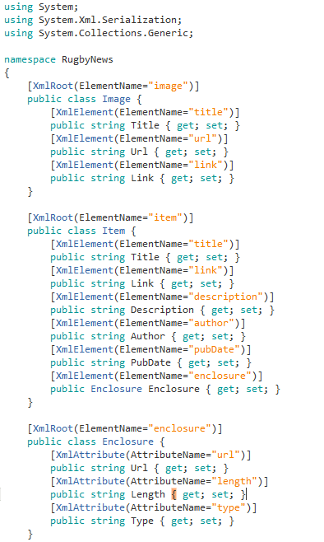

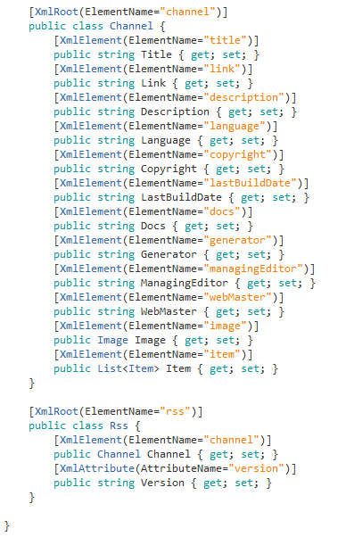

Add the RestSharp component



**RESTHandler.cs file from your previous project**

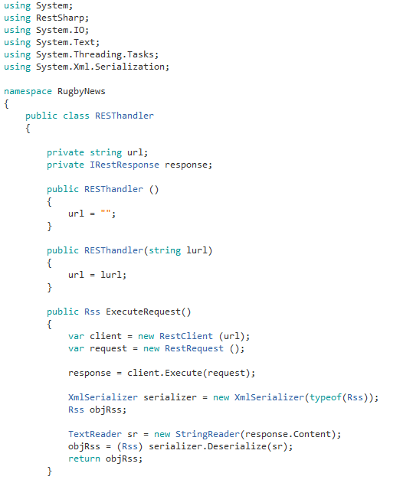

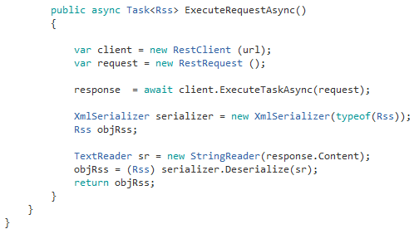

**DataAdapter.cs**

Change the GetView function to display an Image only if it is not null.

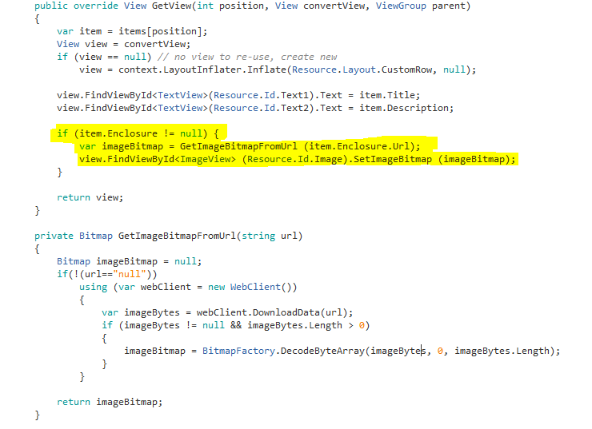

**MainActivity.cs**

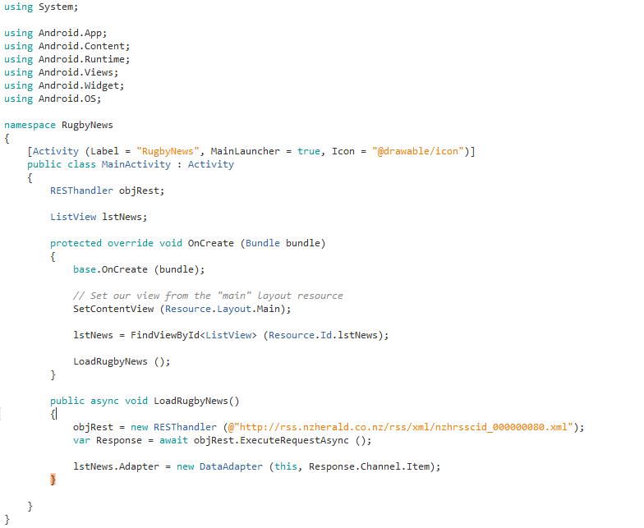

**Exercise**

1. On click of one of the Rugby News items open up its description in another activity in a webview.
2. Modify your project to give users option to view different categories of news (football, Motorsports, Movies etc.)